LEASOWES PRIMARY SCHOOL: CONDOVER RESIDENTIAL 2026 MEDICAL INFORMATION & CONSENT FORM
All participants must complete this form. For all participants under 18, this form should be completed by a parent, guardian, or those with parental responsibility. It should not be completed more than 14 days prior to the visit.
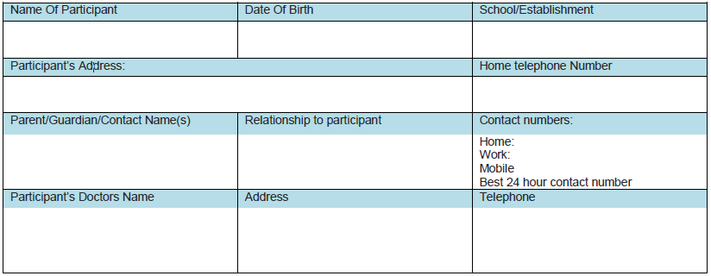
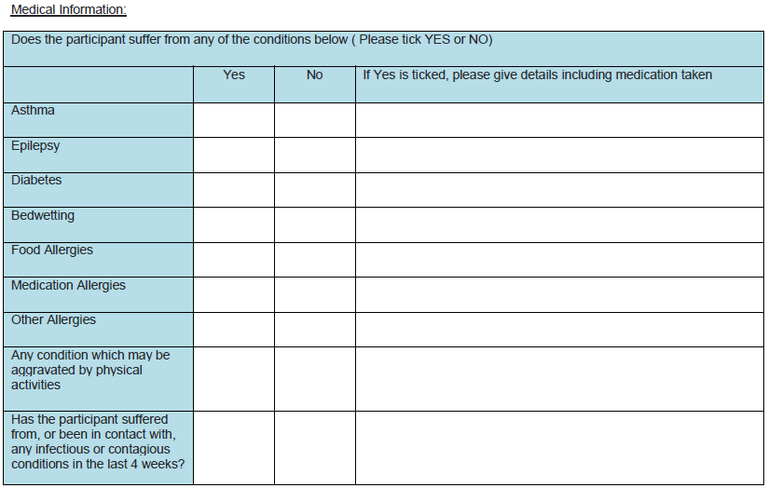

Please give the approximate date of the participants’ last tetanus _______________________
Will the participant need to bring any medications for treatment during the visit? Yes / No
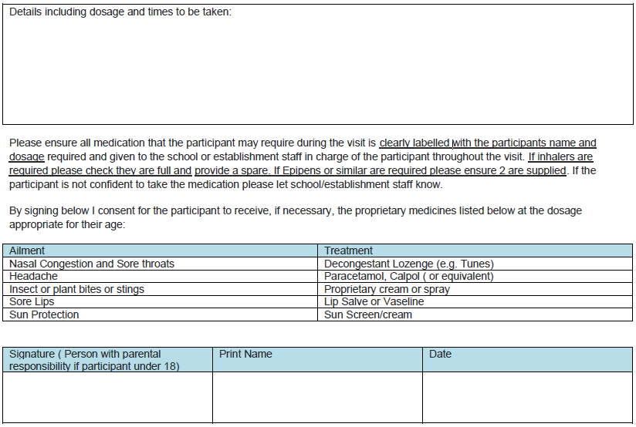
The data provided will be used to ensure the appropriate care and treatment of participants. It will be shared with health professionals as required.

